WISE CRM ERP ADDONS
Wise CRM ERP Addons for Odoo 19
A stronger Odoo CRM operating layer with lead control, dashboards, targets, reports, assignment audit, and employee performance.
Updated Product Portfolio
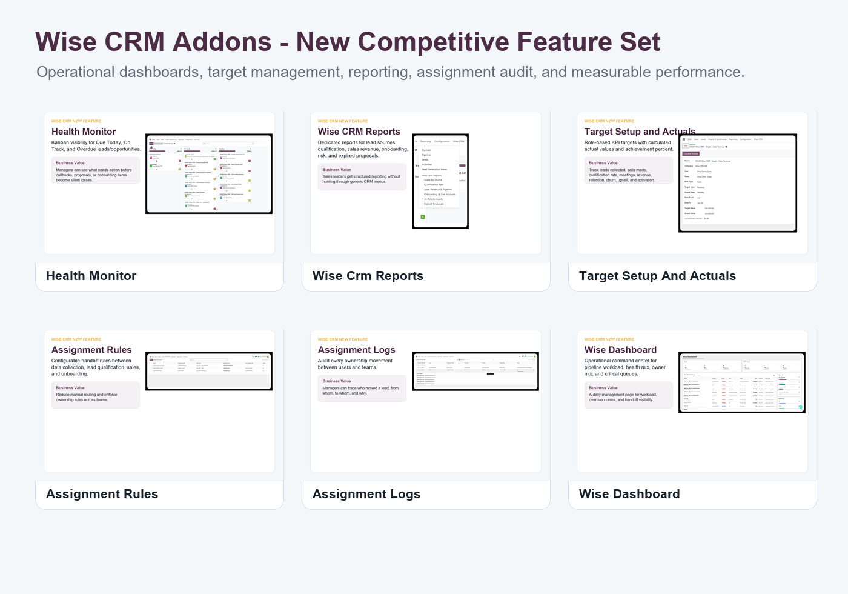

Product Positioning
Wise CRM ERP Addons transforms standard Odoo CRM into a measurable sales operation. It now combines lead capture, qualification, assignment, sales handoff, onboarding, health monitoring, manager reports, target tracking, and employee performance dashboards.

New Competitive Feature Set
Feature | What It Adds | Why It Helps Sell
Health Monitor | Kanban visibility for Due Today, On Track, and Overdue leads/opportunities. | Managers can see what needs action before callbacks, proposals, or onboarding items become silent losses.
Wise CRM Reports | Dedicated reports for lead sources, qualification, sales revenue, onboarding, risk, and expired proposals. | Sales leaders get structured reporting without hunting through generic CRM menus.
Target Setup and Actuals | Role-based KPI targets with calculated actual values and achievement percent. | Track leads collected, calls made, qualification rate, meetings, revenue, retention, churn, upsell, and activation.
Assignment Rules | Configurable handoff rules between data collection, lead qualification, sales, and onboarding. | Reduce manual routing and enforce ownership rules across teams.
Assignment Logs | Audit every ownership movement between users and teams. | Managers can trace who moved a lead, from whom, to whom, and why.
Wise Dashboard | Operational command center for pipeline workload, health mix, owner mix, and critical queues. | A daily management page for workload, overdue control, and handoff visibility.
Employee Performance | Performance dashboard for employee targets, team targets, expected revenue, actual revenue, and critical KPIs. | Connect CRM activity to measurable sales and onboarding performance.

Proof Screenshots

Health Monitor
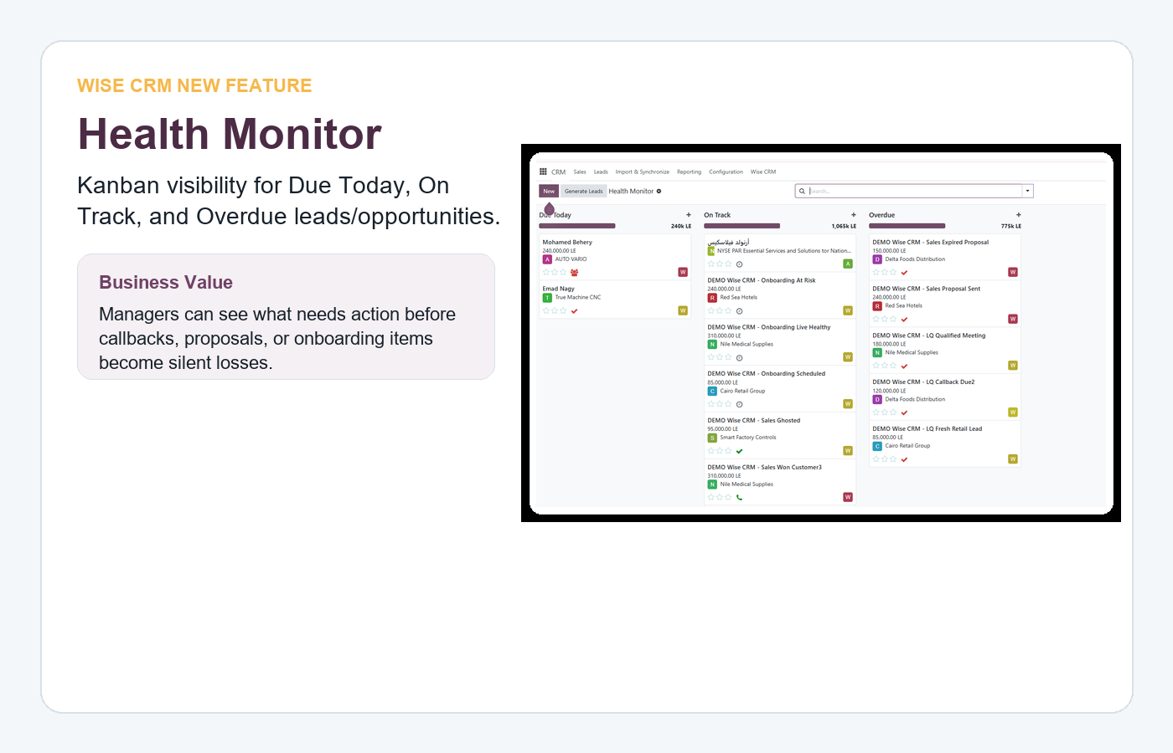

Wise CRM Reports
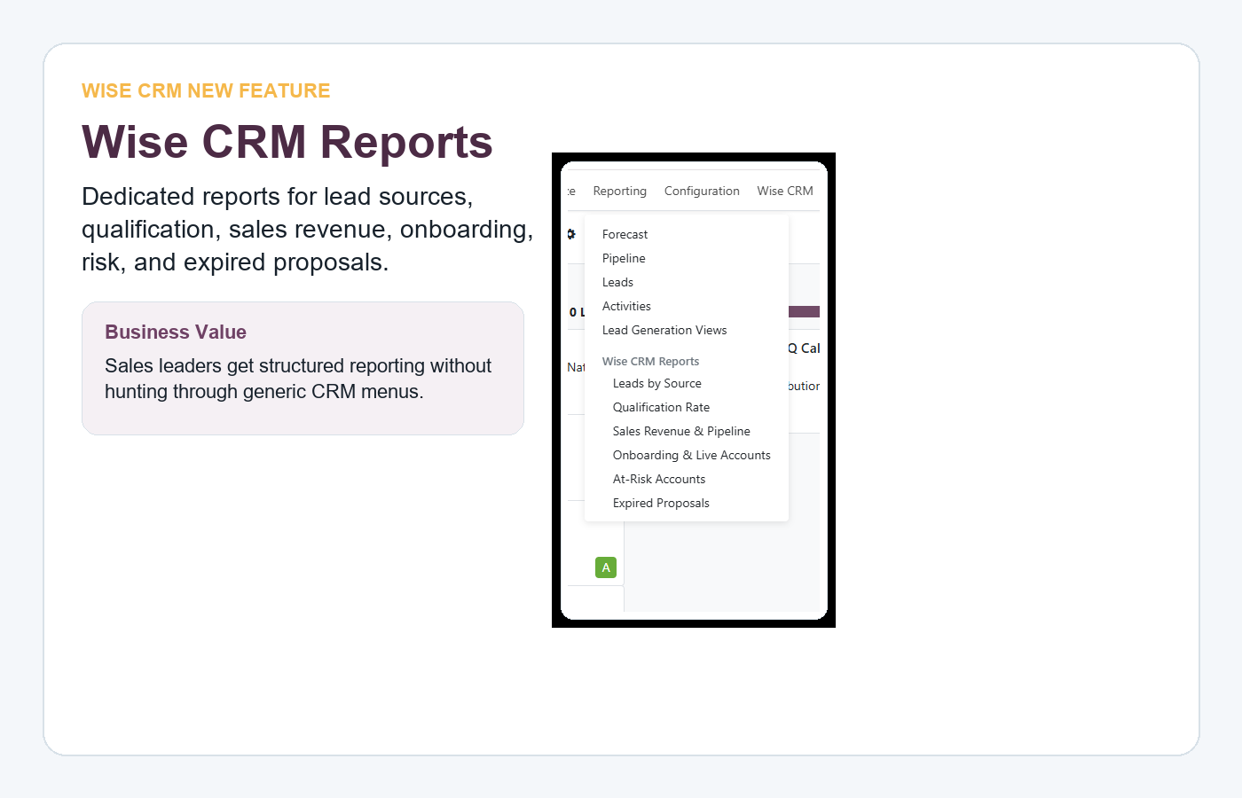

Target Setup and Actuals
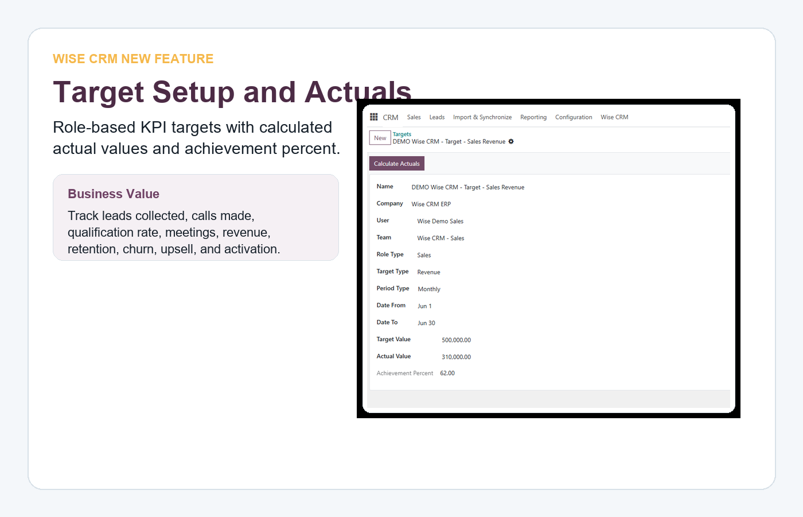

Assignment Rules
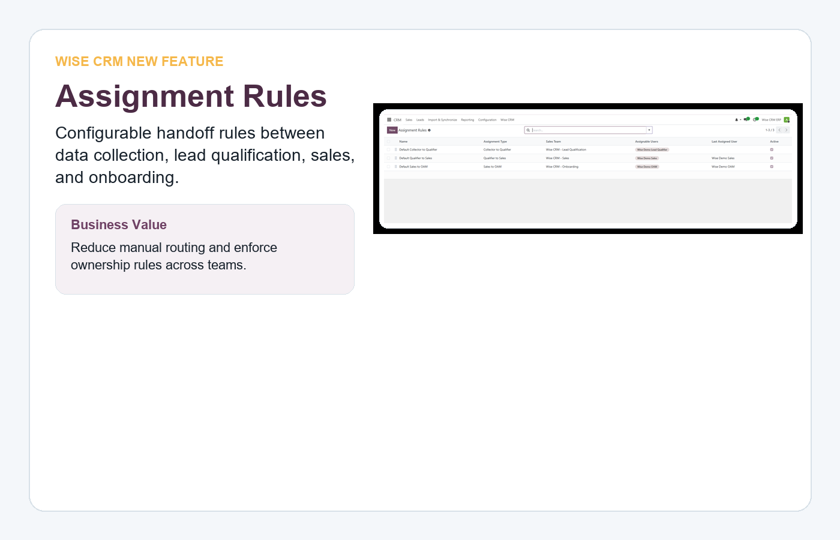

Assignment Logs
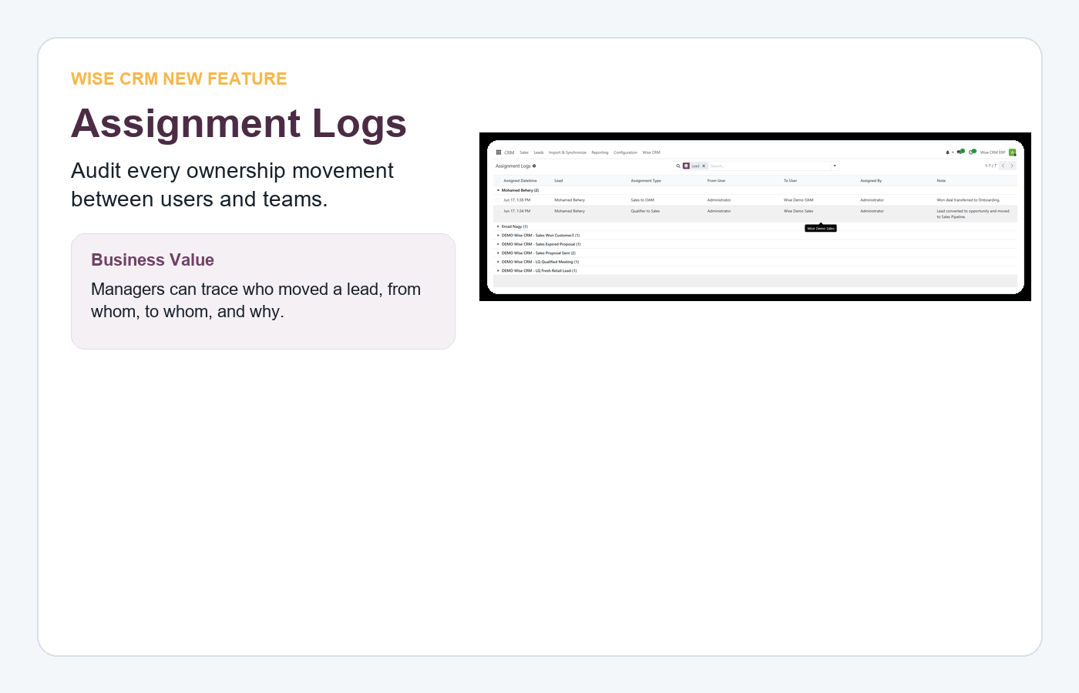

Wise Dashboard
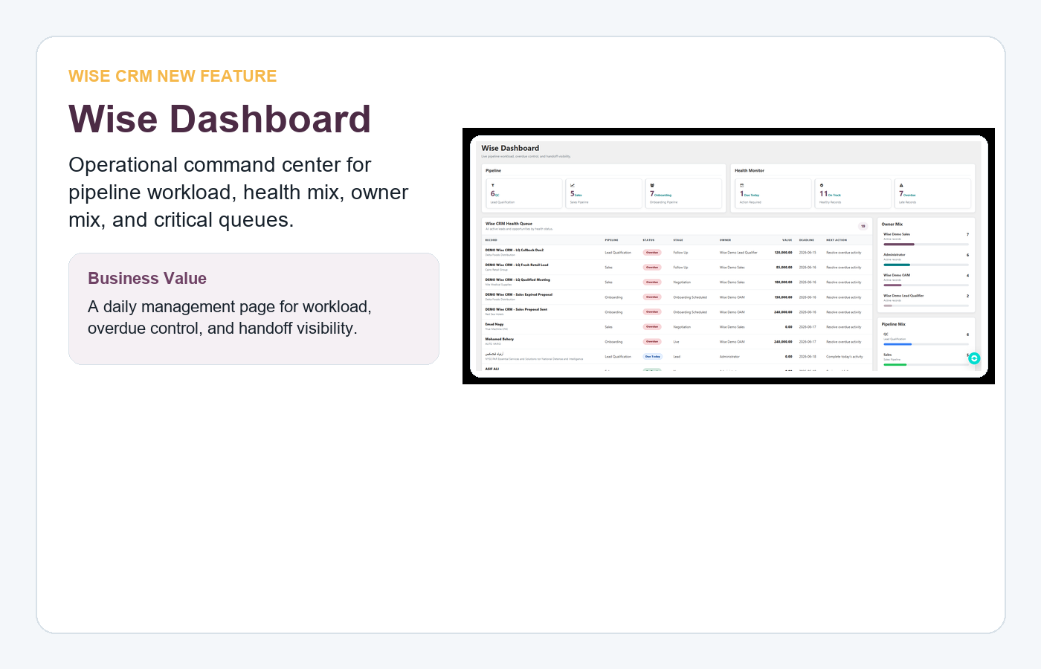

Employee Performance
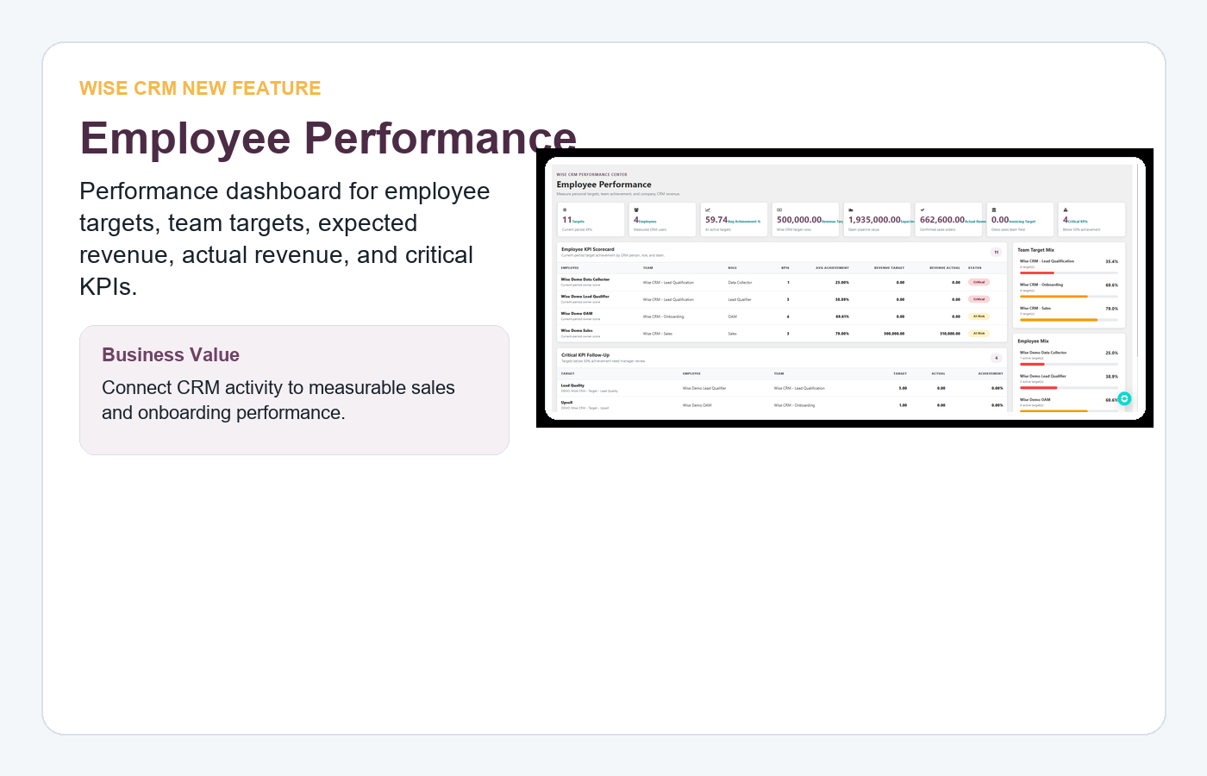

Commercial Message
- Sell it as a CRM operating system, not only custom fields.
- Show management value first: dashboards, target achievement, overdue queues, and assignment audit.
- Use the Employee Performance dashboard to connect CRM activity to revenue accountability.
- Use Health Monitor and Wise Dashboard as daily control-room pages for managers.

Disclaimer
Wise CRM is an independent addon/customization for Odoo 19. It is not an official Odoo Enterprise product and does not include an Odoo license.

