WISE CRM ERP ADDONS
Wise CRM Sales Pitch and FAQ
Updated messaging for the new dashboard, target, report, and audit features.
Sales Enablement Guide
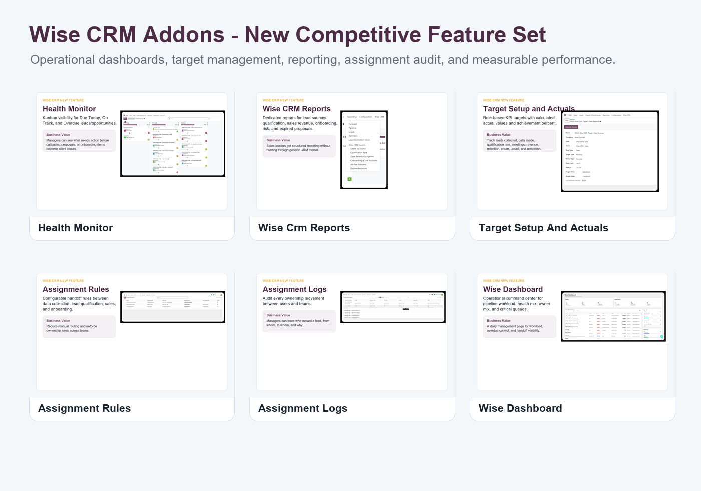

30-Second Pitch
Wise CRM ERP Addons for Odoo 19 turns CRM into a controlled sales operation with lead qualification, assignment rules, sales pipeline, onboarding, health monitoring, reports, target tracking, and employee performance dashboards.

New Strong Selling Points
- Health Monitor makes overdue and due-today work visible.
- Wise Dashboard gives managers a daily command center.
- Employee Performance dashboard measures users against targets and revenue.
- Target Setup calculates actuals and achievement percent.
- Assignment Logs provide an audit trail for every ownership transfer.
- Reports menu gives managers ready CRM reports by source, qualification, sales, onboarding, risk, and expired proposals.

Objection Handling
Objection | Response
We already have CRM. | Wise CRM adds management control, target measurement, and process enforcement around the standard CRM.
How do we track employees? | Use Wise CRM targets and Employee Performance dashboard to compare target, actual, and achievement percent.
How do managers follow problems? | Use Health Monitor and Wise Dashboard to track overdue, due-today, and on-track records.
Can we audit assignments? | Assignment Logs record assignment type, from user, to user, assigned by, and notes.

